
SUPPLIER CODE OF CONDUCT

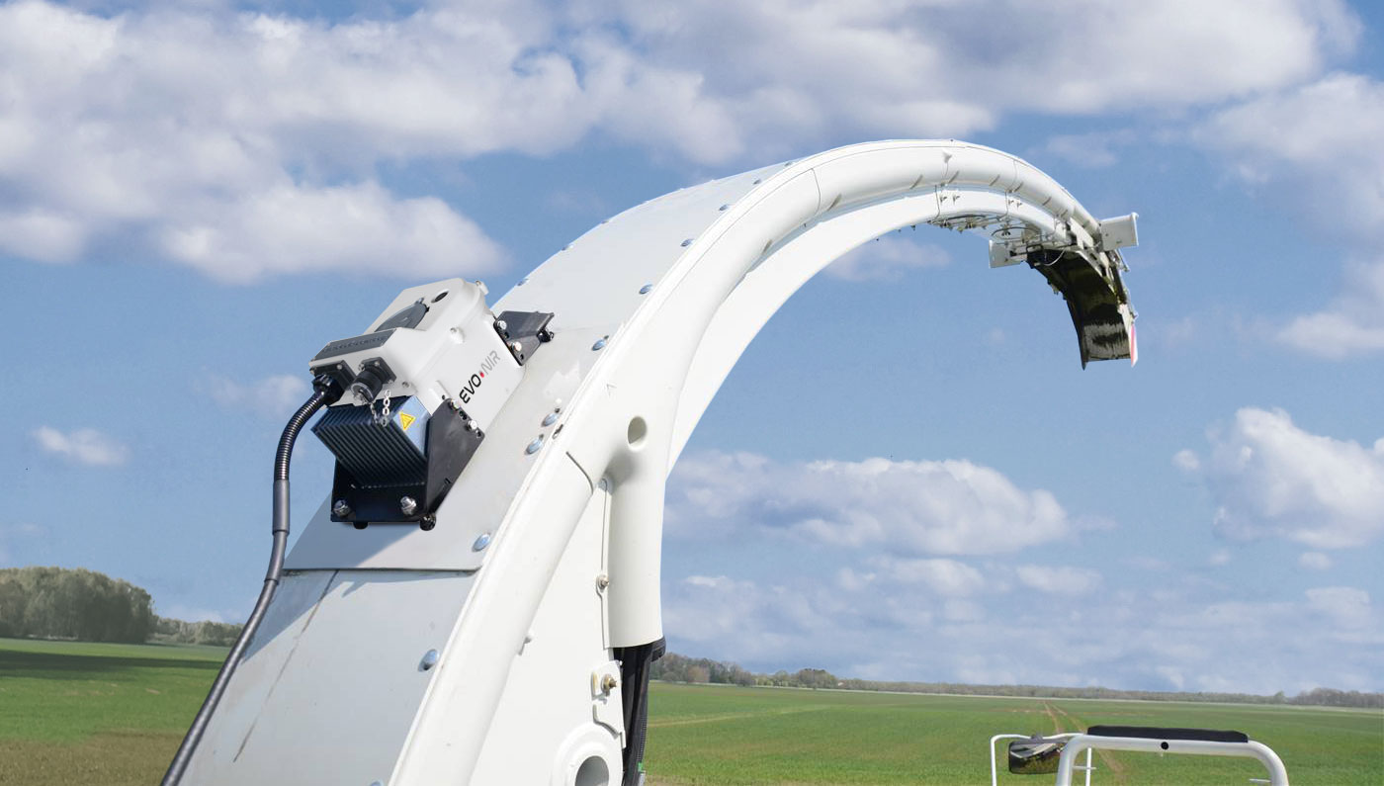



VISION

This Code sets out the conduct that DINAMICA GENERALE expects from its suppliers. It defines the principles and requirements that its suppliers of goods and services, and sub-suppliers, must comply with in terms of their responsibility towards society, the environment and the people involved in the production of goods and/or provision of services.
We expect our suppliers to conduct themselves in accordance with the values, principles and standards to which our company adheres.
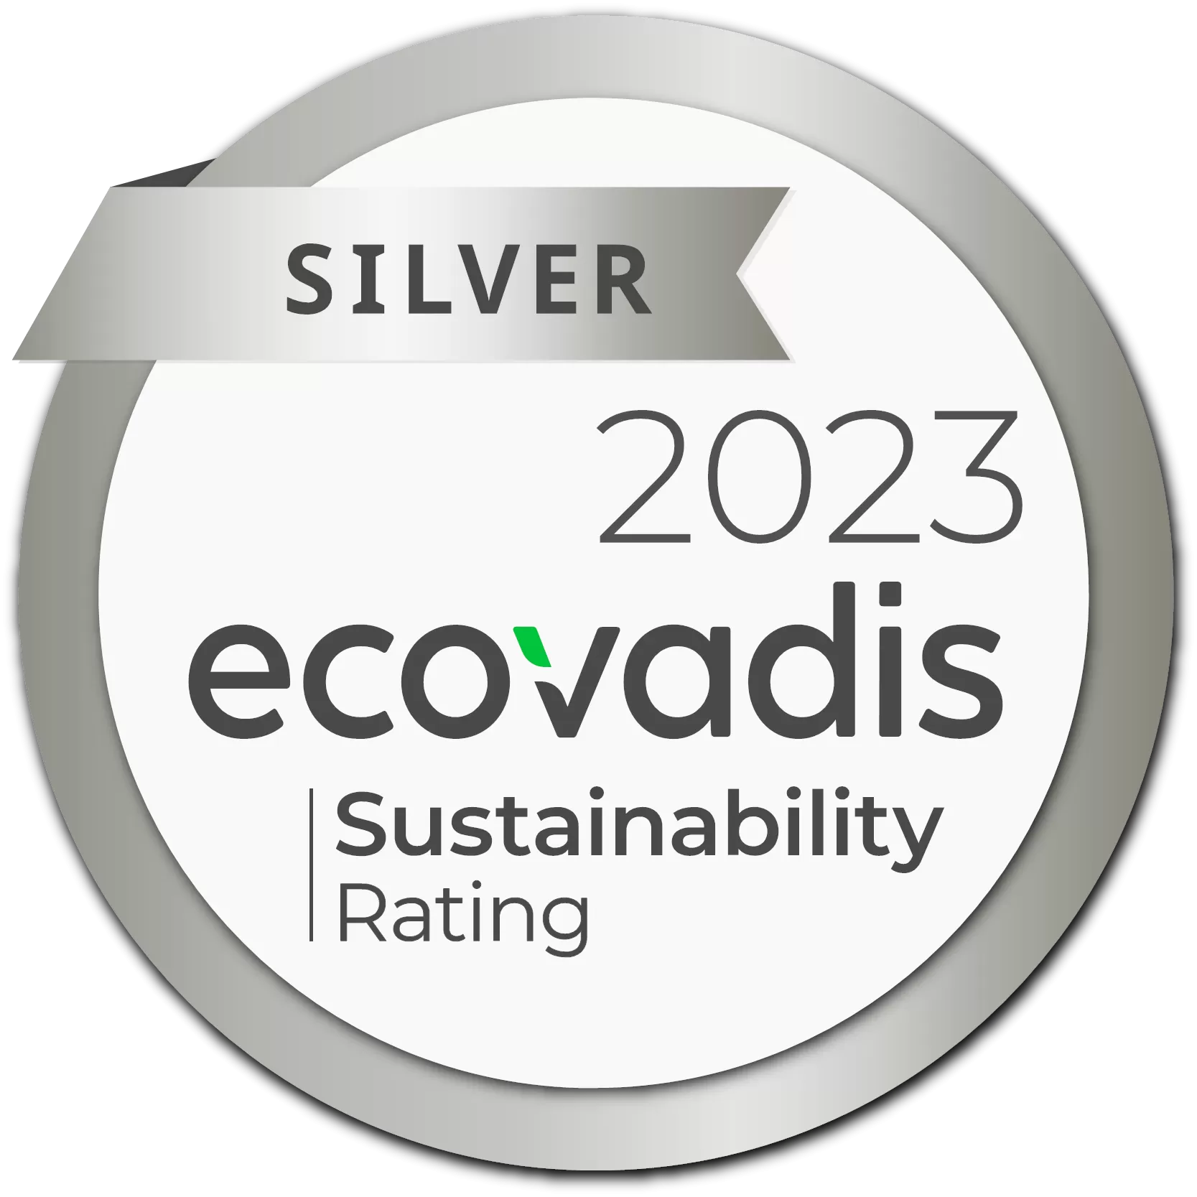
Suppliers are required to comply with the following principles.

MISSION
DINAMICA GENERALE pursues the achievement of the SDGs, Sustainable Development Goals of the 2030 Agenda, with investments in ESG (Environment, Social & Governance) issues and the introduction of a new professional figure specifically for these aspects.

The Sustainability Report for 2024
the Ecovadis Silver Medal for Rating ESG
the goal of Gender Equality Certification
the investment in energy from Renewable Sources
and financing for local communities in the region
are the ingredients for an ecological, social and environmental corporate transition.



LABOUR AND
HUMAN RIGHTS

- Suppliers must not use child labour (under the age of 15) and shall ensure, in compliance with local law, that adolescents under the age of 18 are not employed in hazardous work.
- Suppliers must not use any form of forced labour.
- Suppliers shall ensure respect and protection of human rights, promoting the dignity, health, freedom, integration and equality of all workers.
- Suppliers are required to provide a working environment that ensures respect for and protection of the health, safety and security of every worker, in accordance with current health and safety legislation.
- Suppliers must not tolerate any form of harassment and/or discrimination based on gender, race, religion, age, ethnic origin, marital status, disability or sexual orientation.
- All suppliers must ensure that their workers receive pay and benefits in accordance with applicable regulations and comply with applicable working time regulations.
- Suppliers are required to comply with all applicable laws and regulations aimed at ensuring the freedom of association of workers and recognising the right to collective bargaining.

ETHICS
- DINAMICA GENERALE requires its suppliers to be committed to fair competition and integrity.
- Suppliers must comply with all applicable anti-corruption regulations. They must not perpetrate or tolerate any form of corruption.

- Suppliers shall comply with all applicable data protection regulations. They must act in an appropriate manner to ensure the protection of DINAMICA GENERALE's and its customers' personal data or other personal data whose management derives from the business relationship established with DINAMICA GENERALE.

ENVIRONMENTAL PROTECTION

- Suppliers are required to comply with all legal obligations regarding environmental compliance and to actively engage in environmental protection.
- Suppliers are required to undertake to minimise the environmental impact of their activities, protect local ecosystems and promote the conscious and responsible use of all available natural resources, also supported by the adoption of management systems certified to recognised standards.
- Suppliers are required to commit to actively participate in the process of risk assessment and environmental protection, according to the principles of precaution, prevention and, protection and continuous improvement.
- Suppliers are required to promote the development of technologies and products that limit CO2 emissions and water consumption, as well as recycling and energy-saving solutions.

TRAINING

DINAMICA GENERALE encourages all suppliers to disseminate the principles set out above also through appropriate training of employees in its supplier base.

SUPPLIER'S COMMITMENT

DINAMICA GENERALE requires all suppliers who receive the above-mentioned Supplier Code of Conduct and the attached "Supplier Questionnaire" to return the completed and signed Questionnaire.
By signing the attached Questionnaire, the supplier acknowledges that he has read and accepted all the principles, terms and conditions of the Code in respect of the services and/or components to be provided or supplied to DINAMICA GENERALE.

CEO

